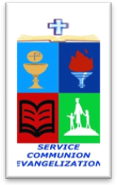
ROMAN CATHOLIC BISHOP OF NOVALICHES
EDUCATIONAL SYSTEM (RCBN-ES, Inc.)
Quirino Highway cor. P. dela Cruz St., Novaliches, Quezon City
Telephone 417-3105

POINTERS TO REVIEW IN SCIENCE 5
School Year 2017 – 2018

FOURTH QUARTER

I. Processes that Shape Earth’s Surface
- Agents of weathering
- Soil erosion

II. Weather Disturbances
- Types of weather disturbances & its formations
- Effects of weather disturbances
- PSWS

III. The Moon
- Phases of the moon
- Beliefs and Practices

IV. The Stars
- Star patterns seen at a particular times of the year

